Anthony Bugatto

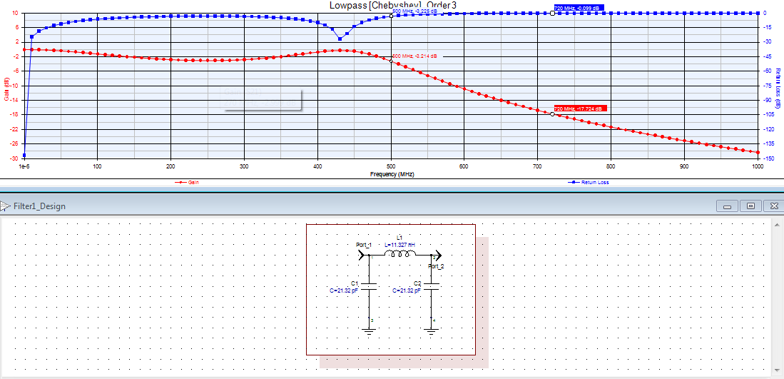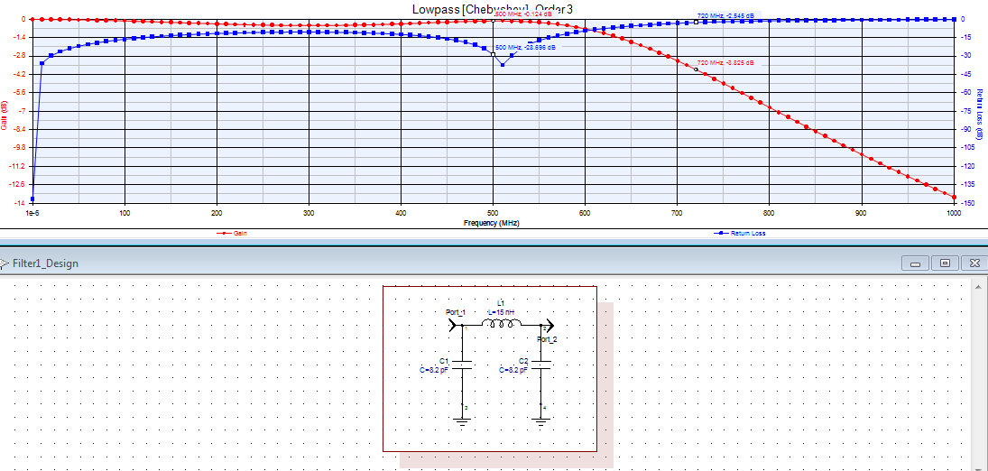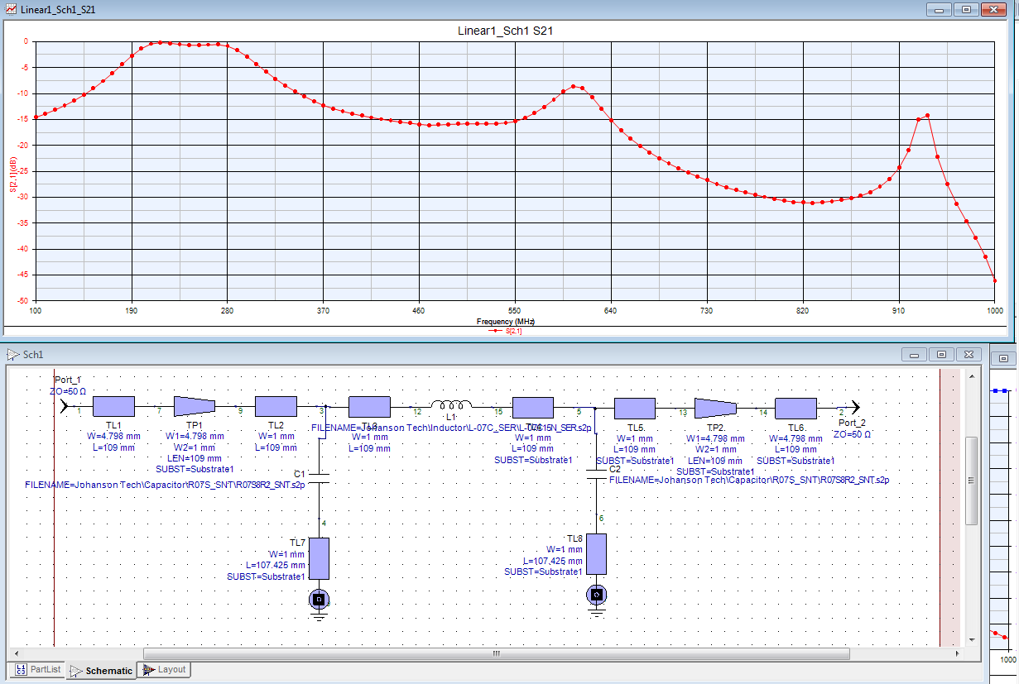

Figure 1: Schematic and Response of Lumped Element Filter

Filter 2: Schematic and Response of Lumped Element Filter with realistic C and L values

Figure 3: The realistic transmission line schematic version of the filter with response

Lab 5: Genysis LPF

April 20, 2018

This lab was to make a low pass filter with -3dB equal ripple (chebyshev) response at 500MHz. The design is third order, which means it should follow the schematic in Figure 1. As we can see, there is a ripple effect and then an attenuation at the cutoff frequency. The dip in the blue indicates the cutoff frequency in the lumped element filter. This was designed using the insertion loss method, which is based off the principle that a filter can be described in terms of a power attenuation polynomial, in this case a chebyshev polynomial, and that we can use the polynomial coefficients to choose the correct values for our lumped elements. Figure 2 shows part 3, which tells us to simulate the filter except with different lumped element values. The response is very similar to the first part. Next we make a realistic version with values from Johnson Tech. From this we get the response in Figure 3 which has a more gradual response compared to the lumped element design. From this transmission line model we create a gerber file to make a fabrication ready filter for testing. Figure 4 and 5 show this albeit in compressed forms. The final response of the transmission line is shown in figure 6.

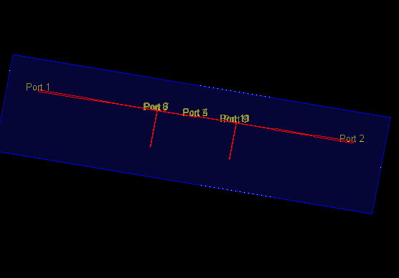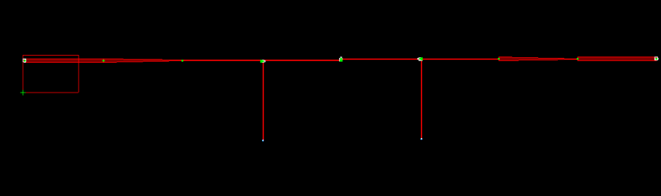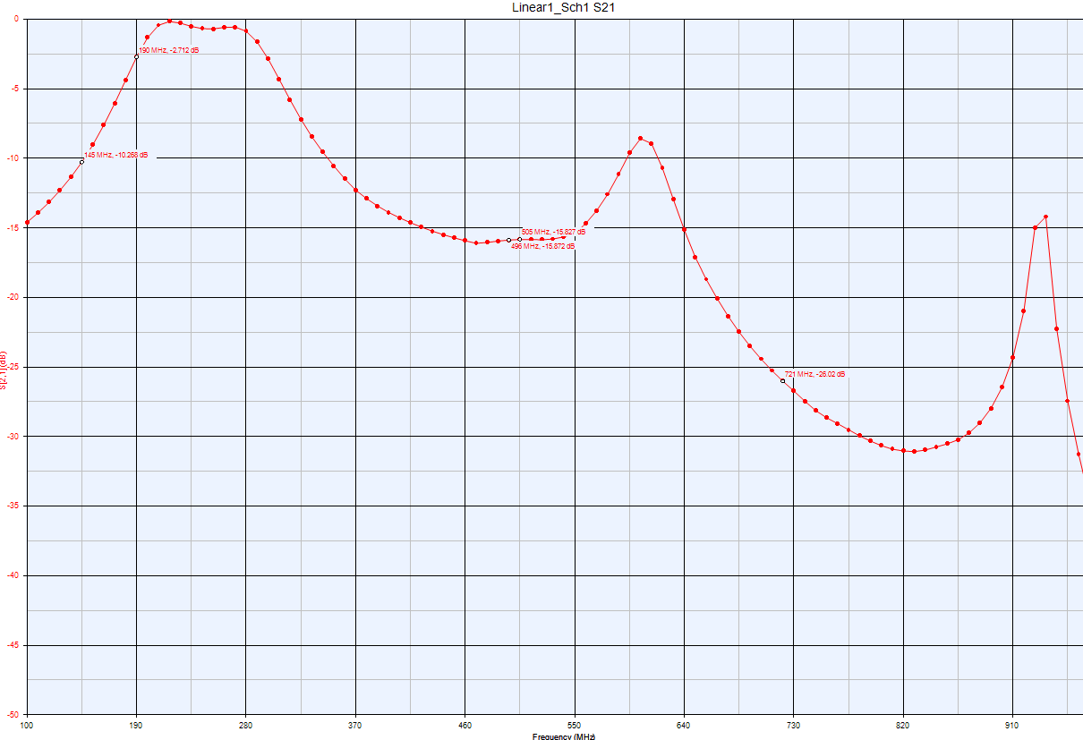

Figure 4: Gerber File

Figure 5: Fabrication ready circuit

Figure 6: Final Response.